Special points
of interest:
- Vacation Bible School returns in June!
- Happy Father’s Day June 17th!
- Fun Puzzles on page 5

Our Savior’s /St. John’s Lutheran Churches
And God blessed them. And God said to them, “Be fruitful and multiply and fill the earth and subdue it, and have dominion over the fish of the sea and over the birds of the heavens and over every living thing that moves on the earth.” Genesis 2:28

Dear Brothers and Sisters in Christ,

Imagine if you will, our world in an unlivable state. The oceans filled with trash, all of the fish and sharks nothing but rotting, stinking corpses. Imagine all of the beautiful trees, nothing but burnt husks of their former beauty. Sounds terrifying does it not? I certainly would not want to live in such a dark and gloomy world!
This is a world that could occur because of our sinful nature. In our hubris, we look to our own desires and wants instead of the needs of those around us. Many times, we do not care who or what we harm so long as we are fulfilled and obtain that which we desire most. We live by the saying, “The ends justifies the means.” and will often times use unsavory means in order to achieve our own ends, even if it means the destruction of nature itself.
How do we stave off such a world? We struggle against our sinful nature, knowing that Jesus has risen and died for us. We know, though the Faith that Jesus has given to us, that all of our sins are forgiven by His great love shown to us on the cross of Calvary. In this love, we seek to follow God's decree. Our Lord in Genesis gives us the dominion and authority over the whole entire earth. He deigns to give us the world and we steward and care for it on His behalf. We celebrate this fact on June fifth World Environment Day. As temporary stewards of this earth, we seek to care for it, protect it and preserve it for generations to come. It means that we do make use of natural resources, but we do so in a way that supports the earth as well. For example, when we cut down trees for lumber or paper products, we plant more as well. It means that we recycle when we can in order to reduce waste and reuse what we are able to. When we go camping or fishing, we seek to leave the location cleaner and better than when we arrived. All of this we do, purely out of our love for God, God's love for us, and in service to our neighbor.
May God grant us the strength we need that we may always be good stewards of His creation until that Day when He makes all things new.

Your Servant in Christ,

Rev. Joshua Reinke

From Rev. Reinke

Dual Parish News

Deuteronomy 5:12–15 2 Corinthians 4:5–12 Mark 2:23–28 (3:1–6)
Christ Jesus Is the Sabbath Rest that Remains for the People of God Forevermore
The Lord brought the sons of Israel out of Egypt “with a mighty hand and an outstretched arm,” in order to give them rest (Deut. 5:15). When He commanded them to “observe the Sabbath day,” therefore, it meant not doing “any work” but resting in His works (Deut. 5:12, 14). So has the same Lord, Jesus Christ, come in the flesh to fulfill the Law and to become our Sabbath Rest. As David “entered the house of God,” and not only “ate the bread of the Presence” but “also gave it to those who were with him” (Mark 2:26), the Lord Jesus entered the Holy of Holies as our great High Priest, in order to feed us with His flesh as the true bread of the Presence of God. As “lord even of the Sabbath,” He works “to do good,” to heal and “to save life” (Mark 2:28; 3:2, 4). He brings us out of sin and death and gives us rest in His own crucified and risen body. Though it is given “in jars of clay,” the life of Jesus is thereby manifested in our bodies (2 Cor. 4:7–11).
Inside this issue:
From Rev. Reinke 1

Lectionary Summary
Week 1 1

Lectionary Summary
Week 2 2

Lectionary Summary
Week 3 2

Calendar 3

Lectionary Summary
Week 4 4

Lectionary Summary
Week 4 4

Kids Page 5
Back Page News 6
Volume 1, Issue 1
June 2018
SECOND SUNDAY AFTER PENTECOST (3 June 2018)

Genesis 3:8–15
2 Corinthians 4:13—5:1
Mark 3:20–35

Jesus Has Defeated the Devil and Released Us from the Bondage of Sin and Death

The devil deceived us, enticing us to disregard and disobey the Word of God and driving us to hide “from the presence of the Lord God.” But the Lord, in His mercy, promised a Savior, who would set Himself against the devil on our behalf (Gen. 3:8–15). The Son of Man came, the incarnate Son of God, conceived and born of the woman. He “first binds the strong man,” Satan, by atoning for the sins of the world, thereby removing the condemnation of the Law and the fear of death (Mark 3:27). Now He plunders the devil’s house by calling all men to repent. Though He appears to be “out of his mind” (Mark 3:21), He fulfills the will of God and makes of us His own brothers and sisters. Therefore, “we do not lose heart,” despite the suffering, sin and death that we experience in this fallen world. “He who raised the Lord Jesus will raise us also with Jesus.” By His grace, we are “being renewed day by day.” For the Gospel is daily bringing us into His presence, not for punishment, but for “an eternal weight of glory” (2 Cor. 4:14–17).

FOURTH SUNDAY AFTER PENTECOST (17 June 2018)

Ezekiel 17:22–24
2 Corinthians 5:1–10 (11–17)
Mark 4:26–34

The Cross of Christ Is the Tree of Life, Which Bears Abundant Fruit after Its Own Kind

The parables of our Lord convey the mysteries of the kingdom of God to those who are “able to hear it,” that is, “to his own disciples,” who are catechized to fear, love and trust in Him by faith (Mark 4:33–34). He scatters “seed on the ground,” which “sprouts and grows” unto life, even as “he sleeps and rises” (Mark 4:26–27). “On the mountain height of Israel,” He plants a young and tender twig, and it becomes “a noble cedar.” Indeed, His own cross becomes the Tree of Life, under which “every kind of bird” will dwell, and in which “birds of every sort will nest” (Ezek. 17:22–25). His cross is our resting place, even while now in mortal bodies, we “groan, being burdened” (2 Cor. 5:1–4). Yet in faith, we live for God in Christ, who for our sake “died and was raised” (2 Cor. 5:15). We know that, in His resurrected body, “we have a building from God, a house not made with hands, eternal in the heavens” (2 Cor. 5:1).

page 2
THIRD SUNDAY AFTER PENTECOST (10 June 2018)

Dual Parish News

“"I am the Lord, the God of every person on the earth. Nothing is impossible for me."
Jeremiah 32:27

June Anniversaries:
Darren and Heather Haapoja June 7, 1987

Charles and Marlys Knutson June 9, 1979

Dennis and Barbara Smith June 12, 1982

Mark and Tami Hawkinson June 13, 1998

Matthew and Tabatha Peters June 15, 2013

David and Tina Jodell June 16, 2001

Ronald and Linda Morosey June 24, 1989

Randy and Elaine Johnson June 25, 1977

June Birthdays:
Mary Weyand June 1
Cassandra Sprague June 2
Gordan Mitchell June 5
William Haapoja June 6
Fred Pelto June 7
Jeff Maker June 7
Brooke Sorensen June 8
Lee Hietalati June 9
Calan Farley June 10
Corey Morosey June 12
Gary Narveson June 18
Doreen Turnock June 23
Nathan Higgins June 26
Jacob Mitchell June 26
Edward Phillips June 28
John Wayrynen June 30

Sunday | Monday | Tuesday | Wednesday | Thursday | Friday | Saturday
 |  |  |  |  | 1 | 2
3 Second Sunday after Pentecost | 4 | 5 | 6 | 7 | 8 | 9
10 Third Sunday after Pentecost  Baby Shower @ St. John’s | 11  Vacation Bible School 9-11:30am @SJ  LWML Meeting @ Our Savior’s 1:00pm | 12  Vacation Bible School 9-11:30am @SJ | 13  Vacation Bible School 9-11:30am @SJ | 14  10:00am Service @ Villa Vista  1:00pm Ladies Aid, 1:30pm Elders, 2:30pm Bible Study @ SJ | 15 | 16
17 Fourth Sunday after Pentecost  Father’s Day | 18 | 19 | 20 | 21 | 22 | 23
24 Fifth Sunday after Pentecost | 25  Vacation Bible School 9-11am @ OS | 26  Vacation Bible School 9-11am @ OS | 27  Vacation Bible School 9-11am @ OS | 28  Vacation Bible School 9-11am @ OS | 29  Vacation Bible School 9-11am @ OS | 30
June 2018
THE NATIVITY OF ST. JOHN THE BAPTIST (24 June 2018)

Job 38:1–11
2 Corinthians 6:1–13
Mark 4:35–41

The Word of Christ Bestows Peace on His Creation through His Forgiveness of Sins

In his anguish and affliction, Job must be reminded that, as a finite creature, he is in no position to question the Maker of the heavens and the earth. Job’s “words without knowledge” are unable to penetrate the wisdom of the Lord (Job 38:1–2). For the Lord has “prescribed limits” and “set bars and doors,” so that “here shall your proud waves be stayed” (Job 38:9–11). That’s how He humbles us unto repentance. But also by His powerful Word, He calms the “great windstorm” and the waves “breaking into the boat.” He does not permit the
FIFTH SUNDAY AFTER PENTECOST (24 June 2018)

Isaiah 40:1–5
Acts 13:13–26
Luke 1:57–80

St. John the Baptist Was Sent to Prepare the Way of the Lord

St. John the Baptist is not the Christ, only His forerunner (Acts 13:25). He was called from the womb to bring Jacob back to God through his Baptism of repentance for the forgiveness of sins (Is. 49:5), just as Christ was the true Servant of the Lord. Miraculously conceived by Zechariah the priest of barren Elizabeth, John was marked to be the greatest born of women (Matt. 11:11). The Church rejoices over the Lord’s mercy just as Elizabeth’s neighbors and relatives did at John’s birth (Luke 1:58). But when Zechariah’s tongue was loosed, John was not the subject of his song. Instead, he said, “Blessed be the Lord God of Israel, for he has visited and redeemed his people” (Luke 1:68). John is the voice crying, “Prepare the way of the Lord” (Is. 40:3); Jesus, the virgin-born Son of God, is that Lord. John is “the prophet of the Most High” (Luke 1:76). He is born “to give knowledge of salvation to his people in the forgiveness of their sins,” because Christ the Dayspring is visiting (Luke 1:76–79). Thus, what John preaches is the comfort of iniquity pardoned by Jesus, the promised Savior of Israel (Acts 13:23), so “that [His] salvation may reach to the end of the earth” (Is. 49:6).

" Through his power all things were made ...things in heaven and on earth, things seen and unseen." Colossians 1:16
chaos of this fallen world to overwhelm us or bring us to despair. By the Word of His Gospel, He speaks “Peace!” to us, which bestows the “great calm” of His new creation (Mark 4:37–39). Therefore, do not be afraid, and do not receive this grace of God in vain. “Now is the favorable time,” and “now is the day of salvation” (2 Cor. 6:1–2).
Dual Parish News

page 4

page 5

KIDS PAGE

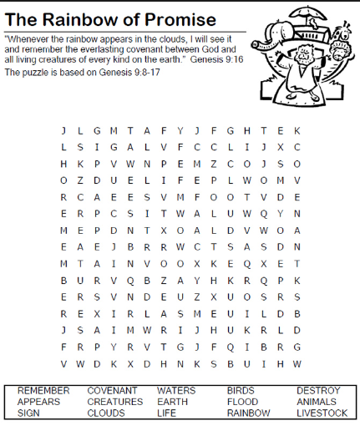
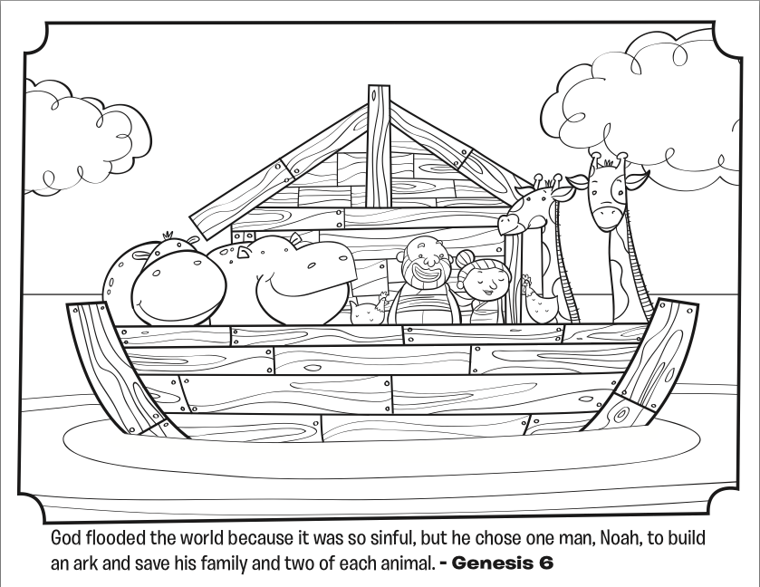

Dual Parish News

About Our Organization…
Vacation Bible School at Our Savior’s will be June 25-29 from 9:00-11:00am. We will be having fun with “Splash Canyon” – God’s Promise on Life’s Wild Ride. Ages 3 thru 6th grade are welcome to attend. Please join us!

VBS packed with
thrills and spills!
Our Saviors Lutheran Church
135 S 1st Street
McGregor, MN 55760
Phone:
(218) 768-3198
E-Mail:
oslutheranmcg@gmail.com
We’re on the Web!
http://oursaviorslutheran church.weebly.com/
Like us on FACEBOOK!

Vacation Bible School at Our Savior’s

Dual Parish News
page 6

A place where the people of God gather around His Word and Sacraments to receive the forgiveness of sins as His witnesses to the world around them.

Our Saviors Lutheran Church
ST. JOHNS LUTHERAN CHURCH
135 S 1st Street
McGregor, MN 55760

